
META-ANALYSIS: EFFECT OF FEV₁ IN ADULTS WITH RESPIRATORY CONDITIONS

TITLE: THE EFFECT OF KINESIOLOGY TAPE ON RESPIRATORY FUNCTION IN ADULTS: A SYSTEMATIC REVIEW

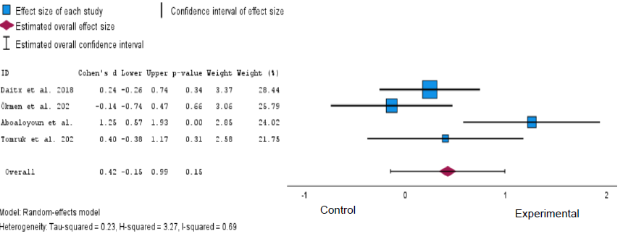
Figure 2: Forest plot displaying the effect of FEV₁ in adults with respiratory conditions

